**TEAM PROJECT ASSIGNMENT 1**

**CINS 370: Group 1**

**Mansi Dogra**

**Viraj Sonavane**

**Adhaar Jaiswal**

The datasets that are shown below are composed of multiple files that are related to each other. These datasets are an attempt to evaluate large volumes of stored data and are important to support new information that can be derived from the stored data. Each data set is the unit to measure the information released in a public open data repository.

The datasets have several attributes that shows the different properties shared among different objects or activities.

**Table 1: Income**

Country Code - It is the short form of different country names.

Region - It describes the different parts of the world.

Income Group - It describes upper and lower level of country income.

Country- It is the list of nations on earth.

Reference : <https://www.census.gov/data/tables/2019/demo/income-poverty/p60-266.html>

**Table 2 : Product**

Region - It describes the different parts of the world.

Country- It is the list of nations on earth.

Item Type - It describes the highest ordered in 2018 by that country.

Reference : <http://eforexcel.com/wp/downloads-18-sample-csv-files-data-sets-for-testing-sales/>

**Table 3 : Immigration**

Port Name - It describes the ship ports in that country.

State - It describes the name of states in specific countries.

Port Code - It describes specific zip code of the ports.

Border - It describes number of inter related crossings between the countries.

Date - It describes the date of immigration.

Container - It lists number of vehicles migrating via border.

Value - It describes the number of people crossing the border.

Location - It describes the latitude and longitude of the border.

Reference : <https://www.kaggle.com/akhilv11/border-crossing-entry-data>

**Table 4 : Population**

State - It describes the name of states in specific countries.

Population - It describes the number of US population in 2018.

Reference : <https://www.kaggle.com/lucasvictor/us-state-populations-2018>

**Table 5 : Poverty**

State - It describes the name of states in specific countries.

People in Poverty - It describes the number of people under or over the poverty line.

Children in Poverty - It describes the number of children under or over the poverty line.

**Reference** : <https://data.ers.usda.gov/reports.aspx?ID=17826>

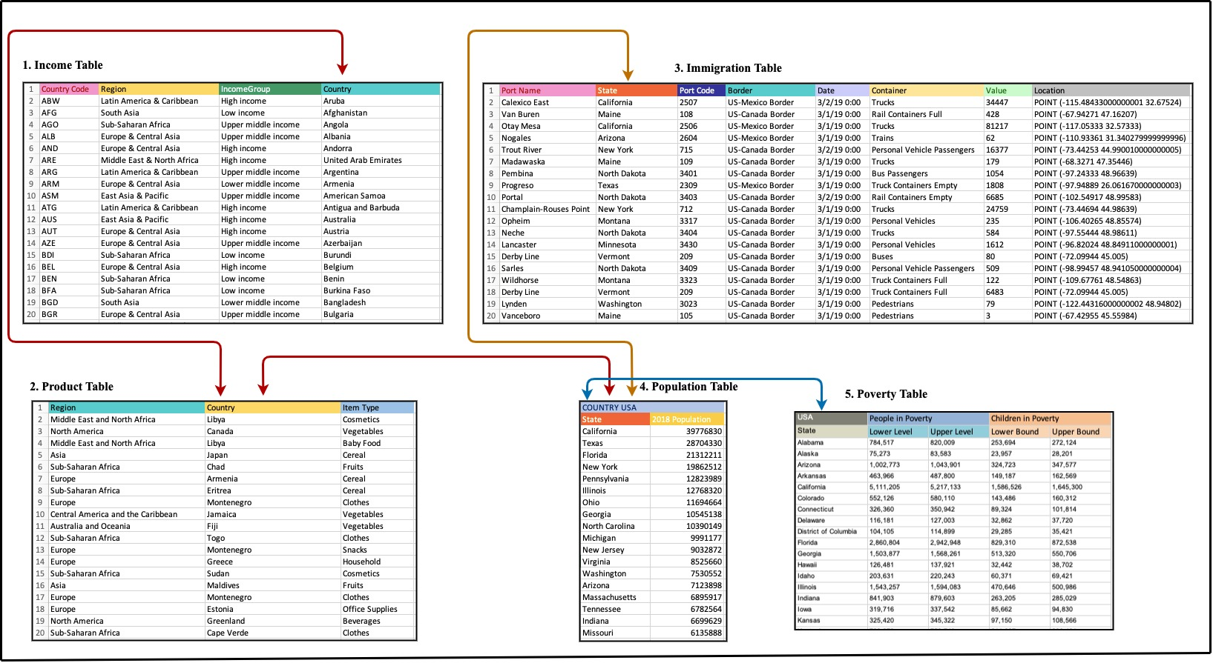

**QUERIES**

1. **How many people crossed the US border between the year 2018-2019?**
2. **How many people are below the poverty line in every state of the US?**
3. **How many countries lie under high income group?**
4. **Which item type product was highly purchased over the time in 2018 by each state of US?**

**5. Compare the number of containers crossing US state border from last 5 years to today.**

**6. Graph visualization of immigration vs population.**

**7. Name the top 5 richest states in the US.**

*(Horizontal view of datasets is attached below)*

**Horizontal View of Datasets**

